# Cloud Computing

* Cloud Computing → Cloud computing is the on demand availability of computer system resources, especially data storage and computing power, without direct active management by the user.
  + Uses of cloud computing
    - Create new apps and services as well as store, back up and recover data
    - Host websites and blogs
    - Stream audio and video
    - Deliver on demand software services
    - Analyze data for patterns
    - Make predictions
* Cloudonomics → Cloud economics is a branch of knowledge concerned with the principles, costs and benefits of cloud computing.
* Economics → foundation of it
  + 1. Utility Pricing
  + 2. Benefits common infrastructure
* Types of Cloud Computing based on cloud location

|  |  |  |  |
| --- | --- | --- | --- |
| Public | Private | Community | Hybrid |
| Whole computing infrastructure is located on the premises of a cloud computing company that offers the cloud service. | Hosting all your computing infrastructure yourself and is not shared. The security and control level is highest while using a private network. | A community cloud is shared between organizations with a common goal or that fit into a specific community (professional community, geographic community, etc.). | using both private and public clouds, depending on their purpose. You host your most important applications on your own servers to keep them more secure and secondary applications elsewhere. |

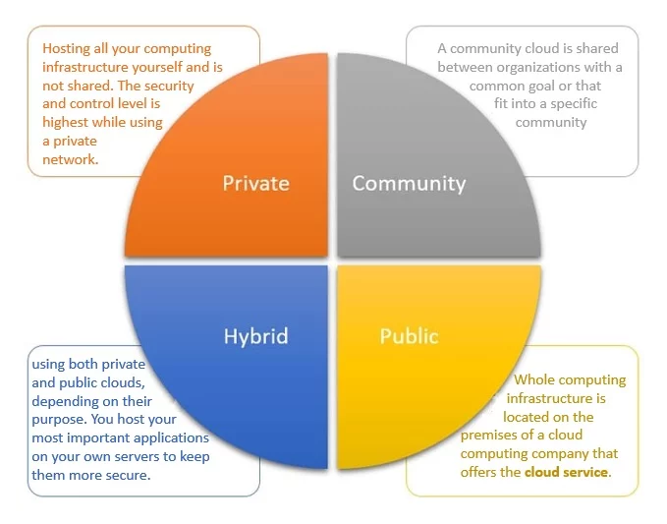

* Types of Cloud Computing based on service

|  |  |  |
| --- | --- | --- |
| Infrastructure-as-a-service ( IaaS ) | Platform as a service (PaaS) | Software as a service (SaaS) |
| IaaS is the most basic category of cloud computing services that allows you rent IT infrastructure (servers or VM’s) from a cloud provider on a pay-as-you-go basis. | Platform-as-a-service (PaaS) refers to the supply an on-demand environment for developing, testing, delivering and managing software applications. It is designed to quickly create web or mobile apps, without worrying about setting up or managing the underlying infrastructure of servers, storage, network and databases needed for development. | Software-as-a-service (SaaS) is a method for delivering software applications over the Internet as per the demand and on a subscription basis. SaaS helps you host and manage the software application and underlying infrastructure and handle any maintenance (software upgrades and security patching). |

* Difference between Cloud Computing and Big Data

|  |  |
| --- | --- |
| Cloud Computing | Big Data |
| Cloud computing is the means of getting information. | Big data refers to voluminous, large sets of data whereas cloud computing refers to the platform for accessing large sets of data.  OR  big data is information |
| Cloud Computing is a technology used to store data and information on a remote server rather than on a physical hard drive. | Big Data is a terminology used to describe huge volume of data and information. |
| Cloud focuses on On-Demand, Elastic, Scalable, Pay-Per Use Self Service models. | Big Data is all about extracting VALUE out of "Variety, Velocity and Volume" (3V) from the Information Assets available |
| Cloud computing is about providing computer resources and/or services over the network | Big Data is about tackling problems faced when the huge amount of data is involved, and traditional methods become infeasible. |
| cloud computing is, what you are giving to end user out of these collected data | Big data is getting all kind of Data |